Toronto Humane Society: Megestrol Acetate Protocol
Approved by: Karen Ward |  | Effective date: 21 April, 2020
Author: Linda Jacobson |  | Revision Date: 17 Jan 2021 updated (LJ)
Purpose | Provide guidelines for the safe use of MGA in cats
Risks | Some potentially serious adverse effects, disclosure required
Main Sources | Progestin contraceptives, ACC-D  https://acc-d.org/available-products/progestin-contraceptives/covid-19-updates  Maddie’s MGA FAQ - Mike Greenberg  https://www.maddiesfund.org/megestrol-acetate-faq.htm?p=245c18ee-b6a3-4881-fa12-1dfaa9bafd6a  Webinar – An emergency contraceptive option for cats during COVID-19 delayed surgery, Joyce Briggs, Michael Greenberg, Julie Levy https://www.youtube.com/watch?v=jSWUWzgt-WU

Background
MGA is a synthetic progestin. It does not replace spay surgery but is a “tool in the toolkit” for preventing unwanted pregnancy in cats when surgery is delayed. This protocol was designed for use during the COVID-19 pandemic but MGA could also be used in carefully selected cases outside of the pandemic response. Use in cats is extra-label. This drug is not recommended as a long-term contraceptive and should only be used as a stop-gap until spay surgery can be performed.

Indications
For interim use to suppress heat and prevent pregnancy. For use in:
      - Homes where a cat is in heat and the behaviour is threatening the integrity of the human-animal bond;
      - Homes where there is a risk of unwanted pregnancy;
      - Colonies pending TNR, where the caregiver is able to get non-pregnant cats to take the medication.

Individual dosing – low-dose MA
      - Compounded liquid 10mg/mL, 6 month half-life
        - Do NOT crush dog tablets (Ovaban), can’t dose safely this way
      - Not in heat: 2.5mg per cat, orally/in food once a week, maximum 30 weeks
      - In heat: 5mg per cat once daily x 3d then 2.5mg per cat per week
      - Dose is approximately 0.625mg/kg, adjust up or down for very small or very large cats
      - Some colony caregivers may be able to dose individually to specific cats; in these situations this dose is preferred

Colony dosing – micro-dose MA
      - Can use at 0.1-0.2 mg/cat once a week, in colonies where individual dosing is not possible
        - Practically speaking, prescribe 1mg per cat per week
        - Unable to control how much each cat gets
        - Unlikely to be harmful but may not be effective
        - Recommend using multiple small plastic or metal plates/bowls to encourage each cat to get its own dose
          - DO NOT use paper, the drug will be absorbed into the paper
          - If unable to provide one plate per cat, provide as many as possible

Warnings and contraindications
- Wear gloves when handling, can be absorbed through the skin
- Do not use in kittens <4 mths of age – can cause uterine changes
- Contraindicated in pregnant cats - can cause stillbirths, mummification, dystocia, kitten malformations, kitten masculinization. Can also cause mammary hyperplasia and queens may not be able to lactate as a result (no direct effect on lactation).
- Safe for lactating queens
- Safe for male cats (has no effect)
- Gentle resuspend before using (suspension not solution)

Adverse effects

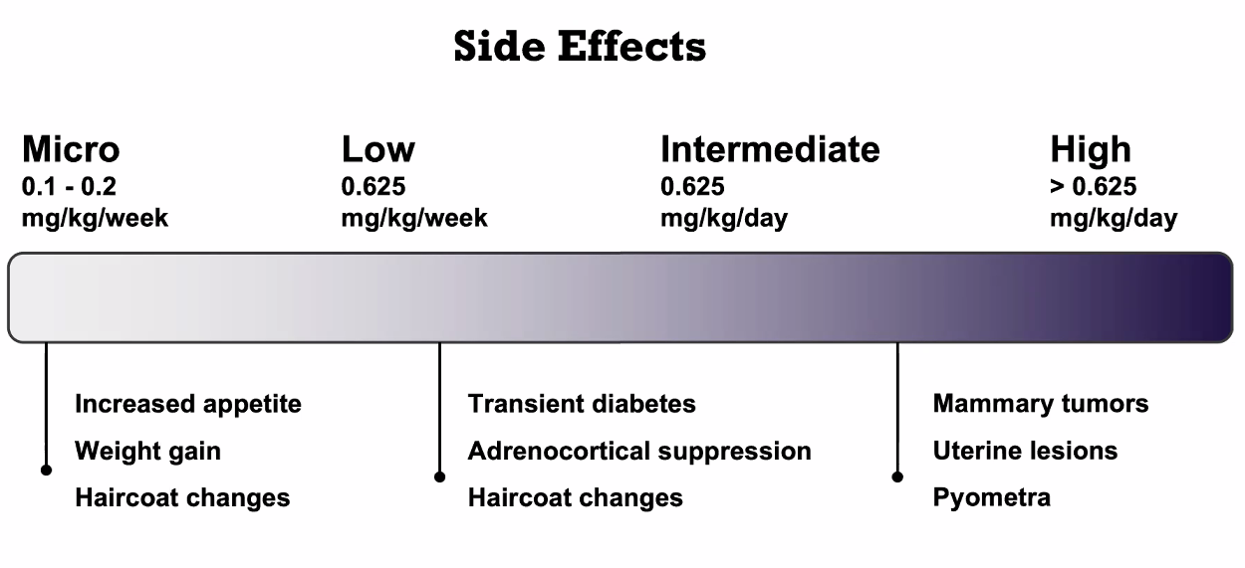

- The doses provided are low and much safer than doses used in the past
- Binds to glucocorticoid receptors. Diabetes and adrenocortical suppression may occur but are transient and stop when the drug is stopped; clinically significant AC suppression appears to be very rare

Prescription and disclosure
- Telemedicine consult required, prescription only by a DVM
- Disclosure needed, as well as ELDU disclosure – see disclosure package for colony caregivers
- Cost to us for the compounded solution is approx. $2.15-$4.20 per mL, 4 doses per mL so approx. 50c-$1 per cat per week [Jan 2021]

